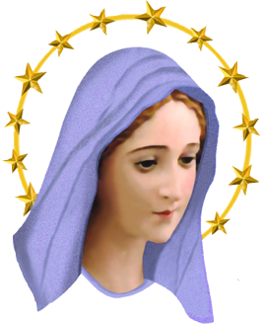

Installation Dinner
May 8, 2025 at 6:30 PM

We will begin at St. Peter’s for the installation of officers at 6:30pm.
Then we will move to Sunset Grill for dinner.

Sunset Grill
25276 W Grass Lake Road
Antioch, IL 60002

Please join us for dinner:
$35.00 per person: cash or check payable to SPWM

Choice of Entree
(anything on the menu except “market price” items)
Choice of Beverage: Coffee, Tea, Soda, ect.
(Cash bar is available separately )

Please RSVP to the office, drop in collection basket, or contact
stpeterswm@gmail.com if you have any questions.

__________________________________________________________

Name_________________________ Guest(s)_________________________
Payment enclosed: $____________
Must be received by Tuesday, May 6, 2025

