St. Peter’s Women’s Ministry presents

Ladies Night Out
Friday, May 2, 2025 7:00 to 10:00 p.m.
Doors Open at 5:30 p.m. with Practice Round at 6:45 p.m.
Parish Hall at St. Peter’s Catholic Church • 2118 Main Street, Spring Grove, IL
Proceeds will go towards fulfilling the Women’s Ministry’s mission of
Making a difference in our parish.
Brought to you by:
Thompson Spring Grove Funeral Home, Spring Grove
Sponsored by:
Roseann Brady, DO, S.C.
Special Thanks to:
Neil J. Anderson, P.C., Spring Grove
Spring Grove Dental, Spring Grove
Spring Grove Physical Medicine, Spring Grove

Join Us for an Evening of Games, Food and Friends
Bunco is an easy dice game and lots of fun to play
Tickets are $35.00 and include:
* All Games * Dessert And Snack Bag * Door Prize Entry
8 players per table - 4 Prizes per table
Raffle tickets sold for $20.00 per sheet
Over 35 raffle baskets to choose from
Sub sandwiches, Water, Soda, Beer & Wine will be available for purchase
(Cash or checks only on day of event)
_ _ _ _ _ _ _ _ _ _ _ _ _ _ _ _ _ _ _ _ _ _ _ _ _ _ _ _ _ _ _ _ _ _ _ _ _ _ _ _ _ _ _ _ _ _ _ Fill out and return this portion together with your check
Payable to: SPWM or St. Peter’s Women’s Ministry
Mail to: St. Peter’s Catholic Church, Attn: Women’s Ministry, 2118 Main Street, Spring Grove, IL 60081
⬜ Signing up as an individual ⬜ Signing up as a group Names In Group
⬜ Seat me with ___________________________ 1. ______________________________________
⬜ All payments included 2. ______________________________________
⬜ Individuals will submit separate payments 3. ______________________________________
4. ______________________________________
Name ________________________________ 5. ______________________________________
Address ______________________________ 6. ______________________________________ Phone ________________________________ 7. ______________________________________ Email ________________________________ 8. ___________________________________ Number of tickets ____ Amount enclosed _________ Return form by Sunday, April 20 or sooner!
Brought to you by:
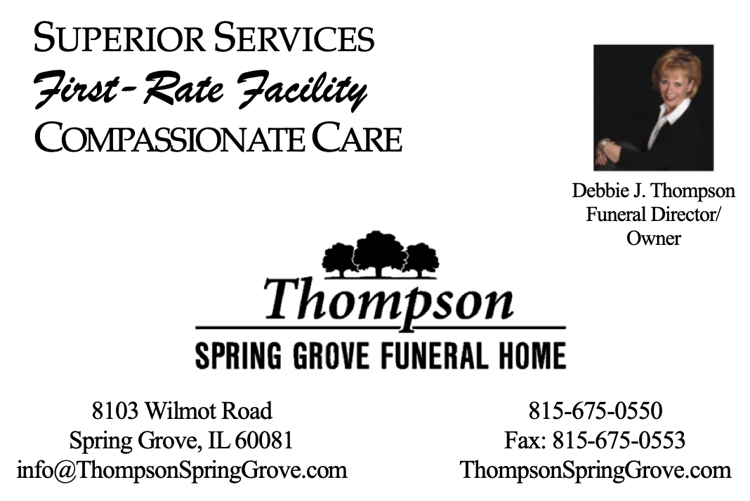
Sponsored by:
Roseann Brady, DO, S.C.
110 S. Wynstone Park Drive, Suite 101
North Barrington, IL 60010
(224)848-4256
Fax: (847)277-9997

